2-STROKE & 4-STROKE OUTBOARD PACKAGES – all of this information needs to show when a viewer clicks on the link



PWC WINTERIZATION – all of this information needs to show when a viewer clicks on the link

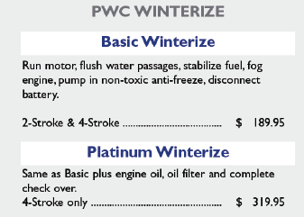

STERN DRIVES – all of this information needs to show when a viewer clicks the link



JET BOAT – all of this information needs to show when a viewer clicks on the link



ADDITIONAL SERVICES – all of this information needs to show when the viewer clicks on the link

